Felicitation of Dr. Nitin Nayak and Ms. Chitra Pandyan

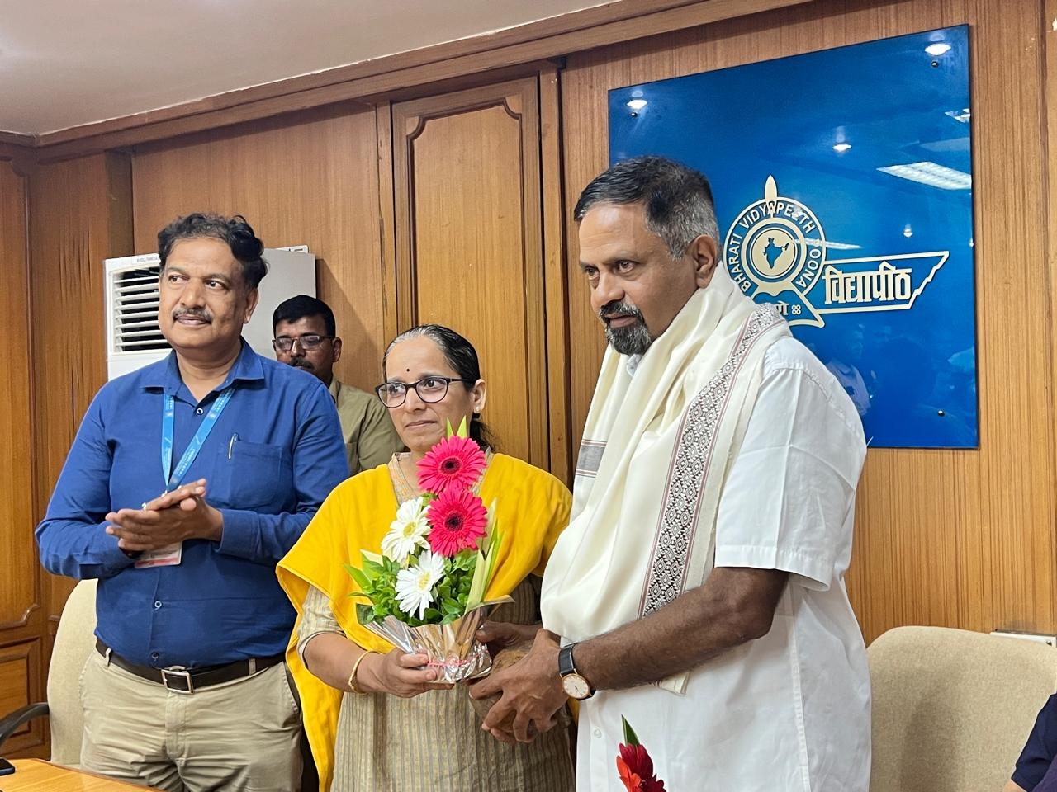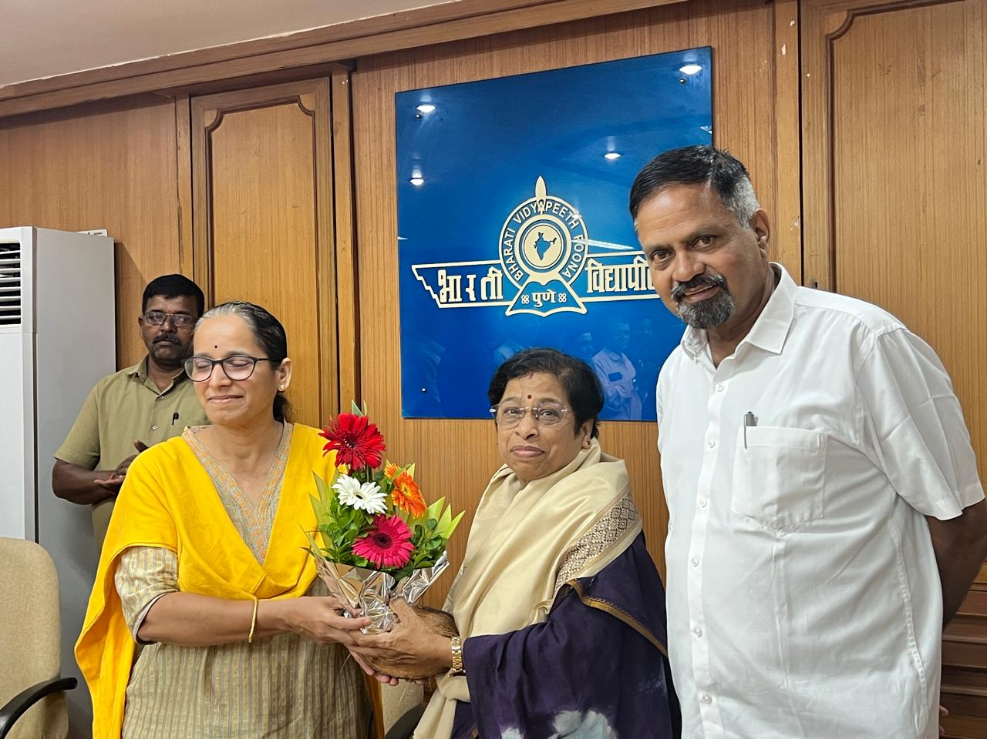
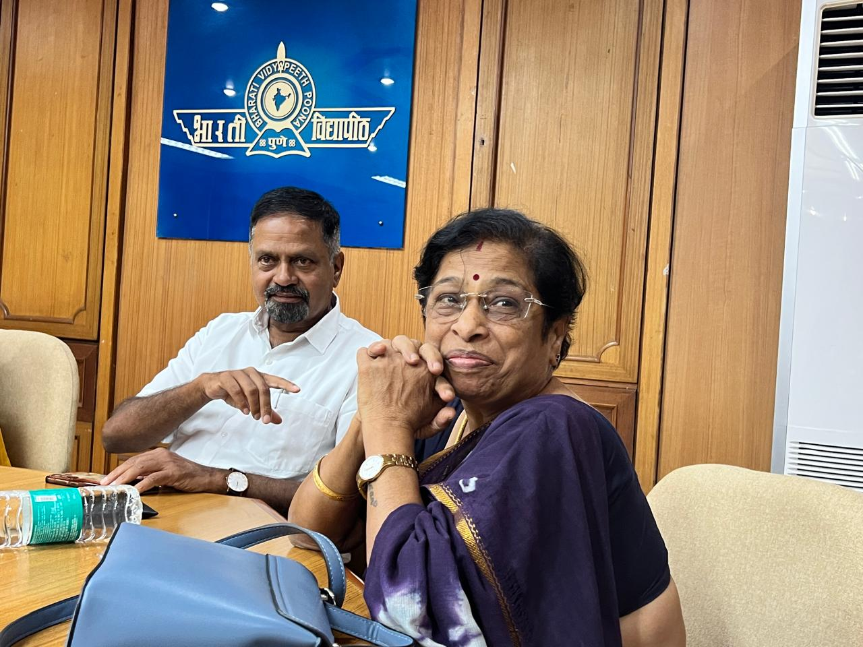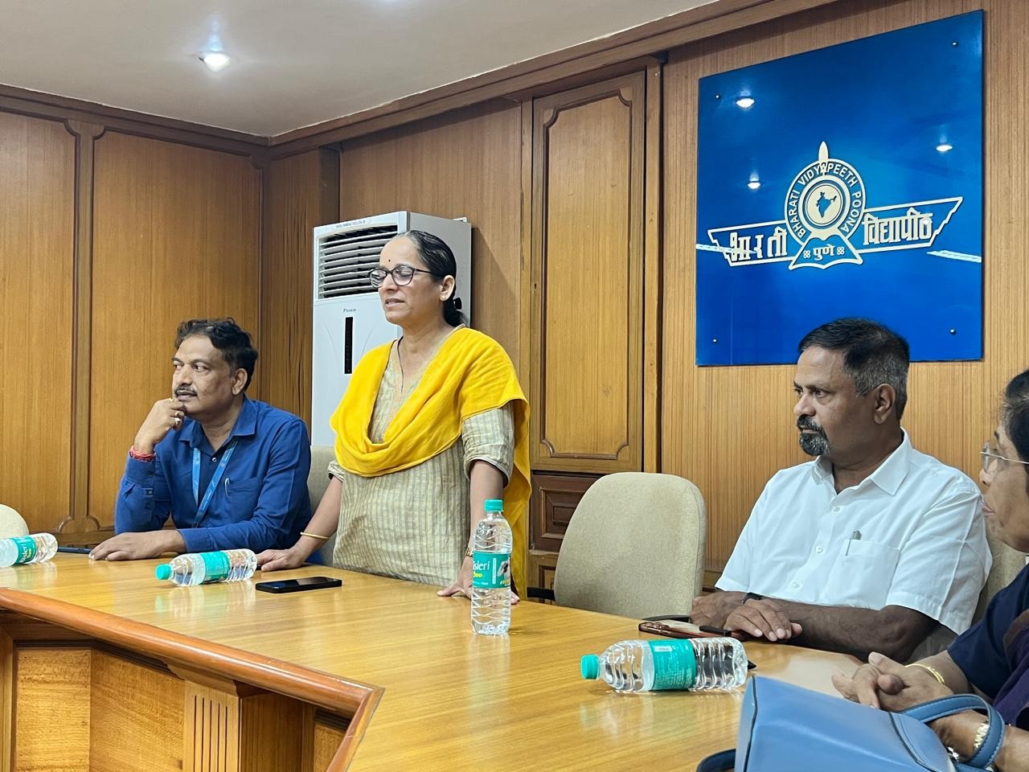
On Wednesday, 21st May 2025 Director Dr. Pallavi Jamsandekar felicitated Dr. Nitin Nayk for being elected as Vice Chairman of Bharati Sahakari Bank Ltd. for the 8th time. She also felicitated Ms. Chitra Pandyan, Director and promoter, Quality Power Electrical Equipments Ltd. Sangli, a leading Indian manufacturer of high-voltage electrical equipment. Quality Power is the first company of Sangli which has gone public. Quality Power Electrical Equipments Ltd. successfully raised a total of ₹858.70 crore through its Initial Public Offering (IPO) in February 2025.
Ms. Pandiyan gave invitation for industrial visit for the students of the institute and offered all the support in internship and placement.
Vice Principal Dr. Pratap Desai thanked both the honoree. All the staff members were present on the occasion.

